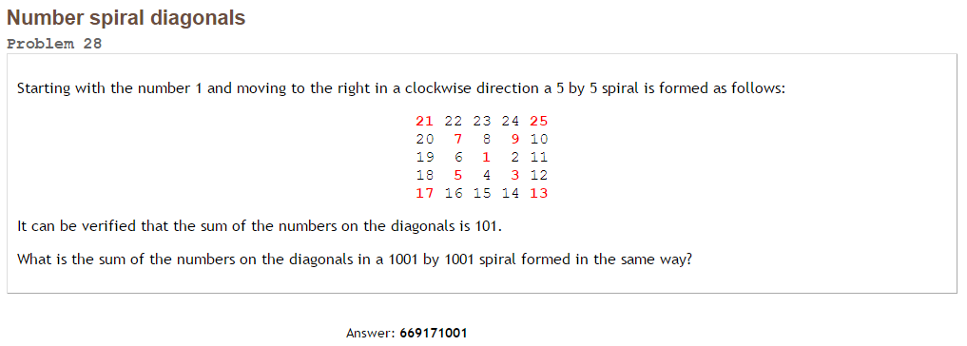Project Euler #28 – Pen & Paper Solution

Looking at the up-right ray, we find the numbers: 

Looking at the up-left ray, we find the numbers: 

Looking at the down-left ray, we find the numbers: 

Looking at the down-right ray, we find the numbers: 

We need to sum all of these (from) and add 1 to the total.



For example, taking, we get: .

Now, if we take  (1001 x 1001), we get: [669171001](http://www.wolframalpha.com/input/?i=16%2F3+*+%28500%5E3%29+%2B+10+*+%28500%5E2%29+%2B+26%2F3+*+%28500%29+%2B+1)